Name : Fariha Arai

AF ID : AF0443236

Lab 9

**1. Write a Python program to Count all letters, digits, and special symbols from the given string**

**Input = “P@#yn26at^&i5ve”**

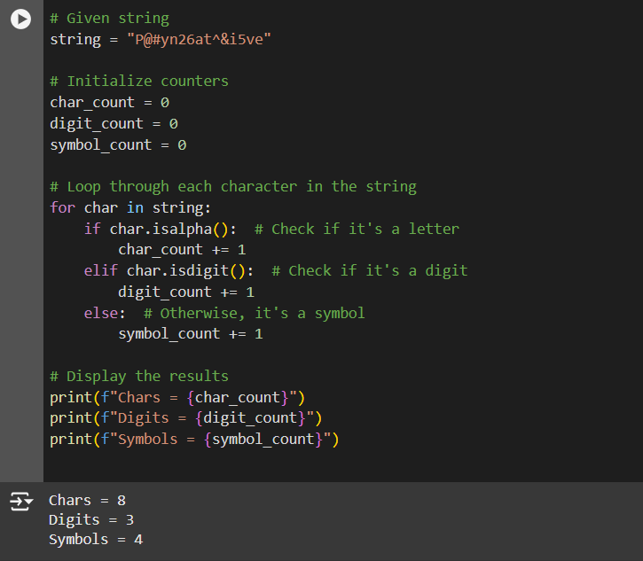

**2. Write a Python program to remove duplicate characters of a given string.**

**Input = “String and String Function”**

**Output: String and Function**

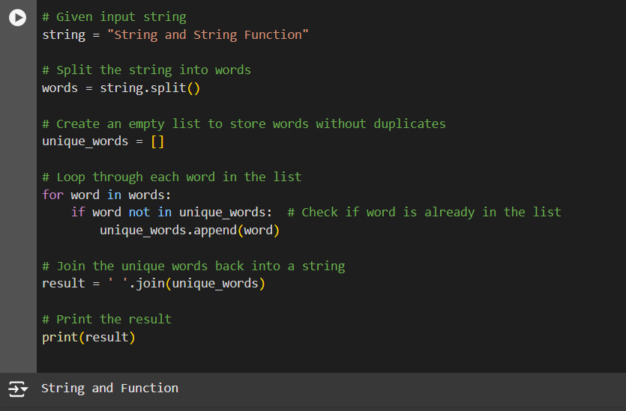

**3. Write a Python program to count Uppercase, Lowercase, special character and numeric values in a given string**

**Input = “Hell0 W0rld ! 123 * # welcome to pYtHoN”**

**Output: UpperCase : 5**

**LowerCase : 18**

**NumberCase : 5**

**SpecialCase : 11**

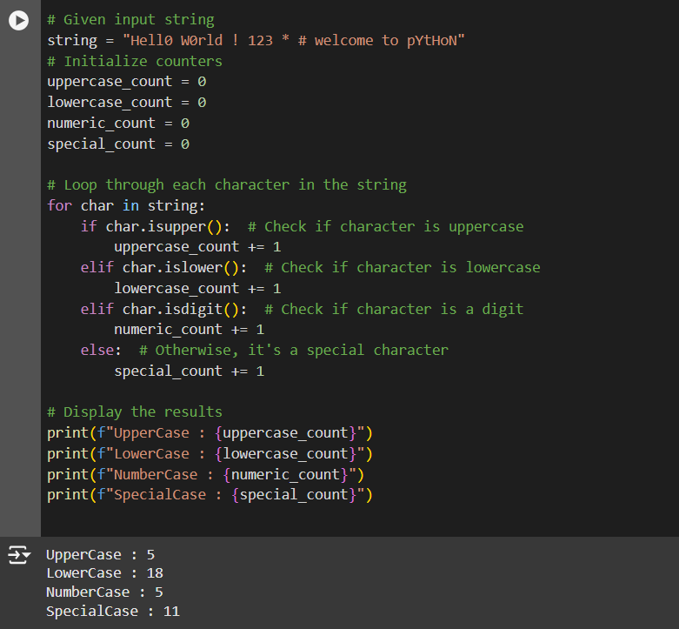

**4. Write a Python Count vowels in a string**

**input= “Welcome to Python Assignment”**

**Output: Total vowels are: 8**

